CS610P: Computer Networks (Practical)
Assignment No. 1
BC240432292
AMNA NAWAZ
Command use for check Default Gateway:
ipconfig /all
Screenshot no 1:
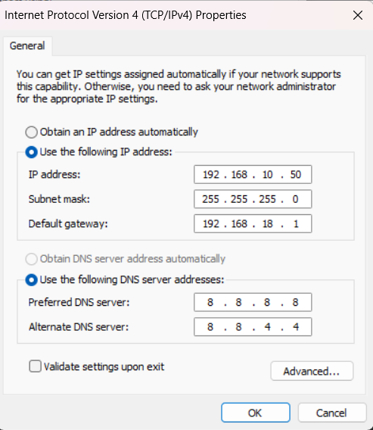
Screenshot no 2:
